

**UNIVERSITY OF ASIA PACIFIC**

Project Name :

IOT Based Smart Home Automation System

**Course Code :**  CSE 316

**Course Title :** Peripheral & Interfacing

|  |  |  |
| --- | --- | --- |
| **Name** | **ID** | **Section** |
| **Ashikur Rahman** | **16201127** | **B-2** |

**Submitted to :**

Abdullah Al Omar

Lecturer , Dept. Of CSE

University Of Asia Pacific.

**INDEX**

* Introduction
* Abstract
* Objective
* Equipment’s

1.Software components

2.Hardware components

* Features
* Goals
* Circuit Diagram
* Flow Chart Diagram
* Working Principle
* Code
* Project Demo
* Challenges
* Future Scopes
* Conclusion
* References
* Journals & other books

**Introduction**

IOT BASED SMART HOME AUTOMATION SYSTEM

With the help of IOT if we control hardware devices through the internet and we control our home appliances, thus automating modern homes through the internet. Then we called it as a IOT Based Smart Home Automation System.

Abstract

We have proposed a system which has the ability to remotely access the home appliances. Many systems we saw that have been used internet, wireless technology to communicate and control home appliances, others used Bluetooth and GSM technology for controlling the home appliances.

The main focus of our project was to build a perfect companion for someone to be at home and the system is integrated with different technology. Generally, home automation research targeted many needs like applications that provide the luxury and smart requirements while some threw light on the special needs for elderly and disabled etc.

OBJECTIVE**:**

1.To construct a wireless home automation system controlled by a smartphone specifically an android device.

2.To design and implement cost effective home automation system yet an efficient one.

3.To design a user friendly and a safe system to control home appliances especially aimed to aid the elders and handicapped.

**Equipment :**

**Software Components :**

1. Google Assistant System

2. Arduino IDE

3. Adafruit IO

4. IFTTT

**Hardware components:**

1. Node MCU 8266

2. Relay Board

**Features**

We implemented into one system. We designed a system to control home appliances using voice recognition .

1. Voice Controlling

Equipment’s**:**

1.Hardware components

Node MCU

Node MCU is an open source IoT platform. Node MCU is a development board featuring the popular ESP8266 Wi-Fi chip. As it turns out, we programed the ESP8266 just like any other microcontroller. Its obvious advantage over the Arduino or PIC is that it can readily connect to the Internet via Wi-Fi. We used it to make the whole process wireless.

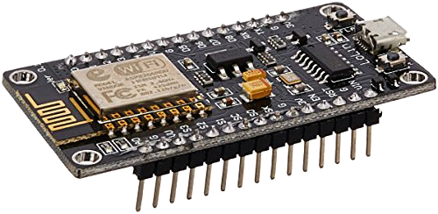

Fig: Node MCU

Relay Board

A relay is an electrically operated switch. Relays we used where it is necessary to control a circuit by a separate low-power signal, or where several circuits must be controlled by one signal. We also used to control power circuits with no moving parts, instead using a semiconductor device to perform switching.

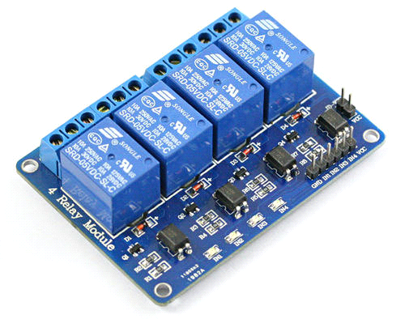

Fig: Relay Board

2.Softwarecomponents

Google assistant

Google Assistant is an artificial intelligence-powered virtual assistant developed by Google that is primarily available on mobile and smart home devices.

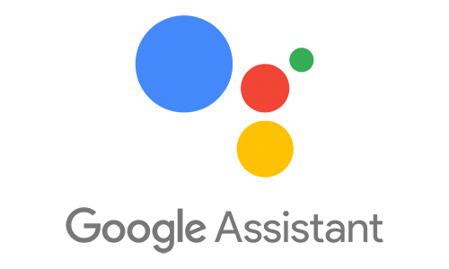

Arduino IDE

The Arduino IDE is incredibly minimalistic, yet it provides a near-complete environment for most Arduino-based projects.

We used this platform for coding.

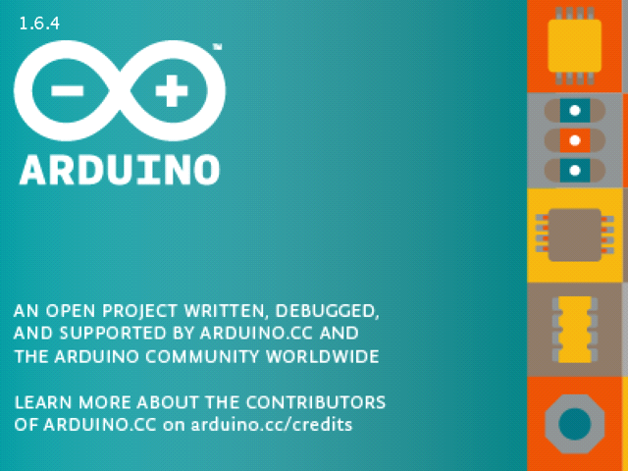

Adafruit IO

Adafruit.io is a cloud service that just means we can run it without managing by ourselves. We can connect to it over the Internet. It's meant primarily for storing and then retrieving data but it can do a lot more than just that. Adafruit.io can handle and visualize multiple feeds of data.



IFTTT

If This Then That, also known as IFTTT is a free web-based service to create chains of simple conditional statements, called applets. An applet is triggered by changes that occur within other web services such as Gmail, Facebook, Telegram, Instagram, or Pinterest.



**Circuit Diagram**

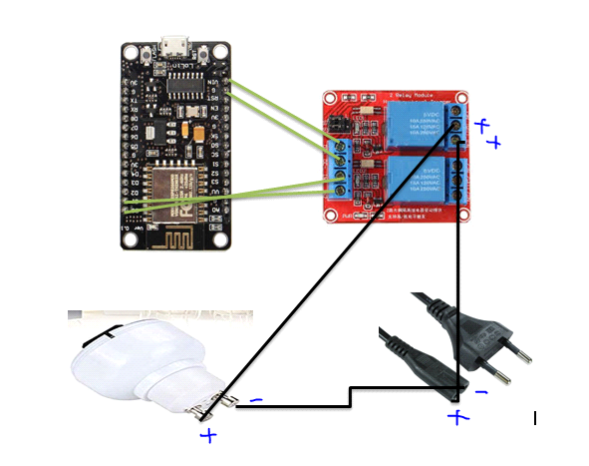

**Flow Chart Diagram**

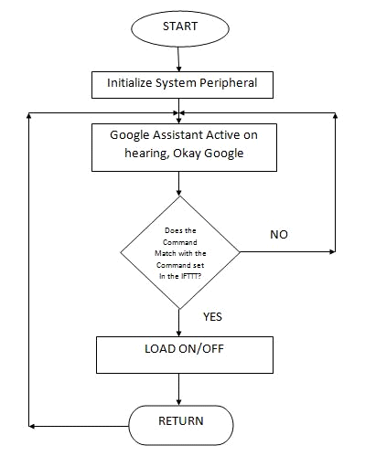

Working Principle

The Arduino Integrated Development Environment - or Arduino Software (IDE) - contains a text editor for writing code, a message area, a text console, a toolbar with buttons for common functions and a series of menus. It connects to the Arduino and Genuine hardware to upload programs and communicate with them. The software, appliances and Wi-Fi module are interfaced with Arduino IDE. The value of instruction brings a change in the status of our appliances. After the successful connection to the server, the data of system are sent to the web server for monitoring of the system. The web server gives the information about the system in different places of the house and motion state in the house. The status of our appliances are uploaded on the web server the user can see the status on his laptop and smartphone as well .The Arduino IDE controls the appliances on the basis of value given by system. It also gives the status of the various electrical appliances like light, fan etc. which we can control remotely.

**CODE :**

//Google Assistant Home Automation

#include <ESP8266WiFi.h>

#include "Adafruit_MQTT.h"

#include "Adafruit_MQTT_Client.h"

#define Relay1 D1

#define Relay2 D2

#define Relay3 D3

#define Relay4 D4

#define WLAN_SSID "Fahim" // Your SSID

#define WLAN_PASS "12345678" // Your password

/************************* Adafruit.io Setup *********************************/

#define AIO_SERVER "io.adafruit.com" //Adafruit Server

#define AIO_SERVERPORT 1883

#define AIO_USERNAME "fahim127" // Username

#define AIO_KEY "165c33d068414182893366554436fb73" // Auth Key

//WIFI CLIENT

WiFiClient client;

Adafruit_MQTT_Client mqtt(&client, AIO_SERVER, AIO_SERVERPORT, AIO_USERNAME, AIO_KEY);

Adafruit_MQTT_Subscribe Light1 = Adafruit_MQTT_Subscribe(&mqtt, AIO_USERNAME"/feeds/Relay1"); // Feeds name should be same everywhere

Adafruit_MQTT_Subscribe Light2 = Adafruit_MQTT_Subscribe(&mqtt, AIO_USERNAME "/feeds/Relay2");

Adafruit_MQTT_Subscribe Light3 = Adafruit_MQTT_Subscribe(&mqtt, AIO_USERNAME "/feeds/Relay3");

Adafruit_MQTT_Subscribe Light4 = Adafruit_MQTT_Subscribe(&mqtt, AIO_USERNAME "/feeds/Relay4");

void MQTT_connect();

void setup() {

Serial.begin(115200);

pinMode(Relay1, OUTPUT);

pinMode(Relay2, OUTPUT);

pinMode(Relay3, OUTPUT);

pinMode(Relay4, OUTPUT);

// Connect to WiFi access point.

Serial.println(); Serial.println();

Serial.print("Connecting to ");

Serial.println(WLAN_SSID);

WiFi.begin(WLAN_SSID, WLAN_PASS);

while (WiFi.status() != WL_CONNECTED) {

delay(500);

Serial.print(".");}

Serial.println();

Serial.println("WiFi connected");

Serial.println("IP address: ");

Serial.println(WiFi.localIP());

mqtt.subscribe(&Light1);

mqtt.subscribe(&Light3);

mqtt.subscribe(&Light2);

mqtt.subscribe(&Light4);

}

void loop() {

MQTT_connect();

Adafruit_MQTT_Subscribe *subscription;

while ((subscription = mqtt.readSubscription(20000))) {

if (subscription == &Light1) {

Serial.print(F("Got: "));

Serial.println((char *)Light1.lastread);

int Light1_State = atoi((char *)Light1.lastread);

digitalWrite(Relay1, Light1_State);

}

if (subscription == &Light2) {

Serial.print(F("Got: "));

Serial.println((char *)Light2.lastread);

int Light2_State = atoi((char *)Light2.lastread);

digitalWrite(Relay2, Light2_State);

}

if (subscription == &Light3) {

Serial.print(F("Got: "));

Serial.println((char *)Light3.lastread);

int Light3_State = atoi((char *)Light3.lastread);

digitalWrite(Relay3, Light3_State);

}

if (subscription == &Light4) {

Serial.print(F("Got: "));

Serial.println((char *)Light4.lastread);

int Light4_State = atoi((char *)Light4.lastread);

digitalWrite(Relay4, Light4_State);}

}

}

void MQTT_connect() {

int8_t ret;

if (mqtt.connected()) {

return;

}

Serial.print("Connecting to MQTT... ");

uint8_t retries = 3;

while ((ret = mqtt.connect()) != 0) {

Serial.println(mqtt.connectErrorString(ret));

Serial.println("Retrying MQTT connection in 5 seconds...");

mqtt.disconnect();

delay(5000);

retries--;

if (retries == 0) {

while (1);

}

}

Serial.println("MQTT Connected!");

}

Challenges

* Management of various equipment
* Home design & sensor layout
* Time consumption
* Decision making for automation
* Robotic Control
* Advance Security

**Future Scopes**

* There are a lot of other sensors that can be used to increase the security and control of the home like motion sensor to detect that someone will enter the home.
* Changing the way of the connection by using the Ethernet shield to make this system more professional.
* The range of Wi-Fi modules have to be enhanced.
* We can develop a smart thermostat that is able to automatically gauge the temperature of a room and then adjust the central heating and cooling units as necessary

Conclusion

This project undertakes a viable solution of the need of automation at the very basic level, that is, in our homes. The use of a WIFI module assists the use of this system from various locations in our house with the help of voice other side if we are outside of the house, we can also control it with the help of IP server. This system, though primarily aimed to reduce human effort, will be of much importance to old aged people and physically disable people. It will enable them to control their home devices with ease, without going through much pressure or stress of moving about.

References

• <https://io.adafruit.com/>

• <https://ifttt.com/>

• <https://www.youtube.com/watch?v=1goTMGq26wE>

END